Final Project Reflection

For the final project, I added the 3D scene objects in addition to my controller that is based on the dual sense PS5 controller color in purple illustrated here

. 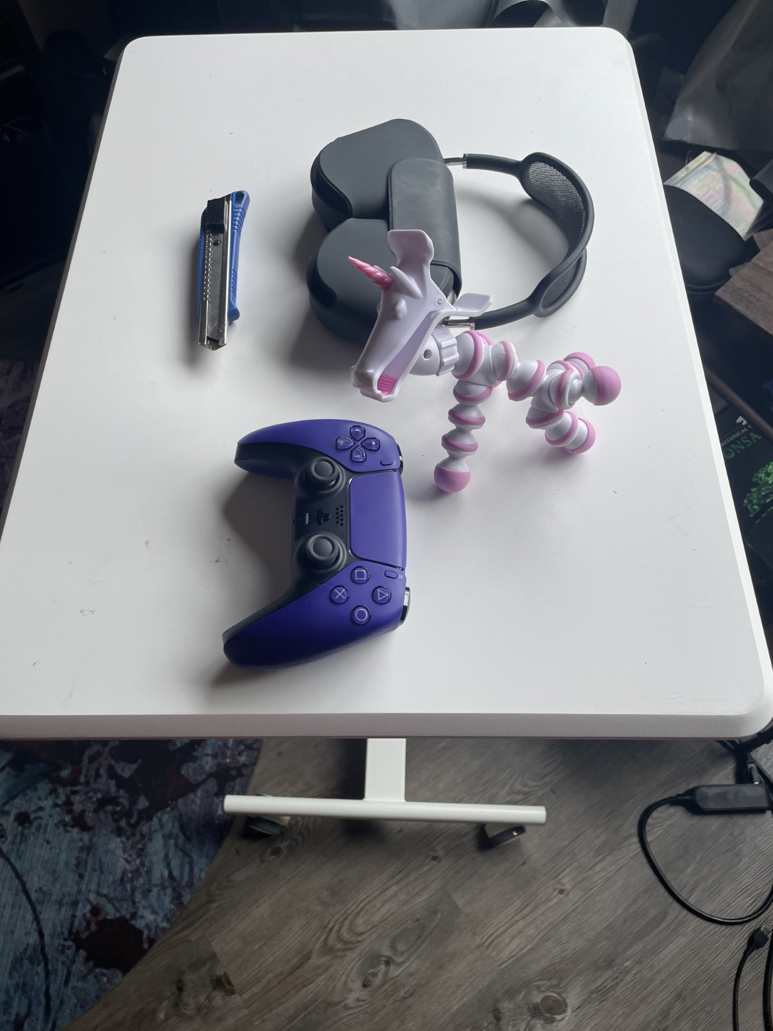  
The original object consisted of 16 objects, so that quickly limited my ability to add new objects. In order to overcome this I had to shift from rendering all objects at once.

I also used functions like CreateGLtexture() and SetShaderTexture(() to make sure they were rendered.

For the lighting portion, I didn’t use all the lights available for simplicities sake. So instead I used 2 light sources, which was one directional light and a purple tinted point light. They both used the Phong model, which includes ambient, diffuse, and specular parts. This allows the objects to be seen clearly from different angles.

For the camera movement, I implemented the wasd keys to move forward, left, back and right, and QE for up and down. The mouse allows movement around and the scroll whell changes how fast the camerage moves. Lastly pressing P switches from 2D to 3D(perspective and orthographic).

Functionality

In order to maintain stability and organization functions like SetTransformations, setShaderTexture() and RenderScene() were used independently to avoid a huge block of code and for redundancy.

Overall I was able to meet all the requirements of 4 low-poly objects, with the controller being my complex object. I used 4+ different shapes, textured them, and used 2 lights utilizing the phong lighting model. The camera movements along with the ability to switch between perspective and orthographic. Overall I had a lot of fun and definitely learned alot.